**AI Lab Record**

1. Write a Python program which accepts the user's first and last name and print them in reverse order with a space between them

Ans-

fname=input("What is your first name ? ")[::-1]

lname=input("What is your last name? ")[::-1]

print(lname+" "+fname)

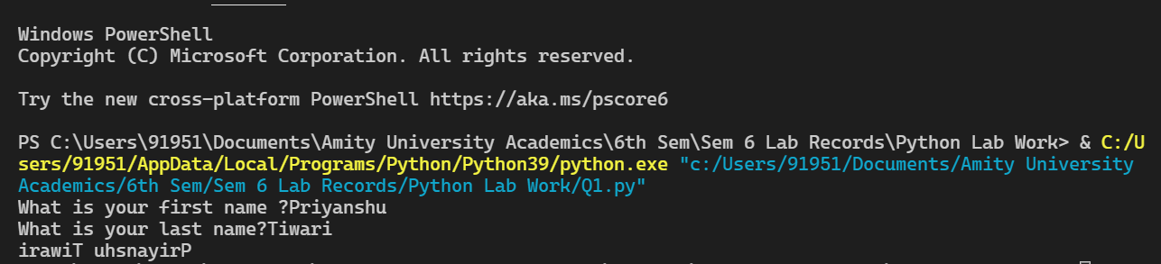

1. Write a Python program to find whether a given number (accept from the user) is even or odd, print out an appropriate message to the user.

Ans-

num=int(input("Enter a number : "))

if num%2==0 :

print("Even Number")

else :

print("Odd number")

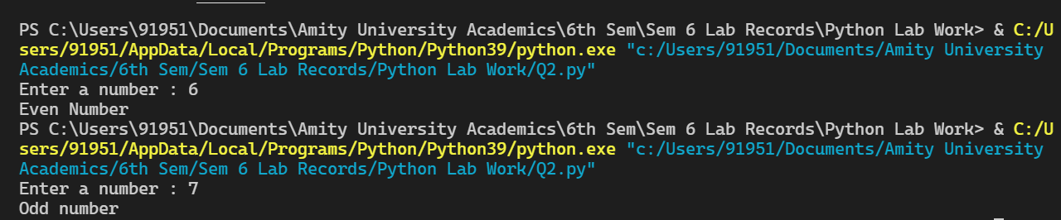

1. Write a Python program which accepts the radius of a circle from the user and compute the area.

Ans- radius=float(input("Enter radius of circle : "))

area=3.14*radius*radius

print("Area of circle is : "+str(area))



1. Write a Python program to get the difference between a given number and 17, if the number is greater than 17 return double the absolute difference.

**Ans –**

**num=int(input("Enter a number : "))**

**diff=num-17**

**if num>17 :**

**print(abs(2*diff))**

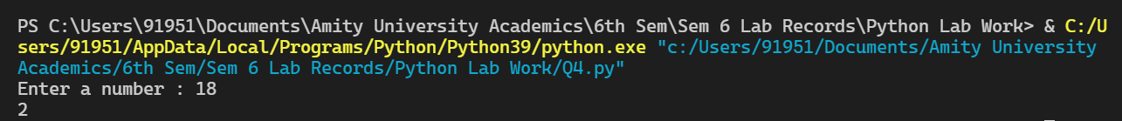

1. Write a Python program to calculate the sum of three given numbers, if the values are equal then return thrice of their sum

Ans-

a=int(input("Enter first number : "))

b=int(input("Enter second number : "))

c=int(input("Enter third number : "))

if a==b==c :

print("Sum is : "+3*(a+b+c))

else :

print("Sum is : "+str(a+b+c))

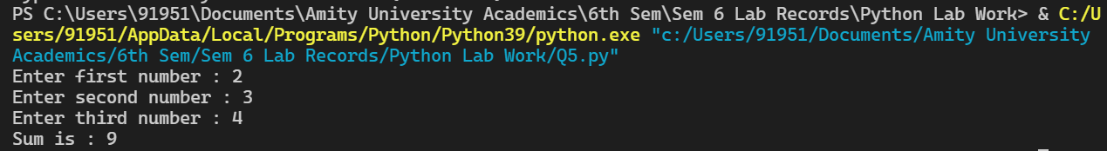

1. Write a Python program to count the number 4 in a given list.

Ans :

from collections import Counter

list=[1,2,4,4,3,2,5,6]

x=4

d=Counter(list)

print("4 occured in the list "+str(d[x])+" times")



1. Write a Python program to compute the distance between the points (x1, y1) and (x2, y2).

x1=int(input("Enter x1: "))

y1=int(input("Enter y1: "))

x2=int(input("Enter x2: "))

y2=int(input("Enter y2: "))

distance= ((x2-x1)**2+(y2-y1)**2)**0.5

print("Distance between two points is: ",distance)

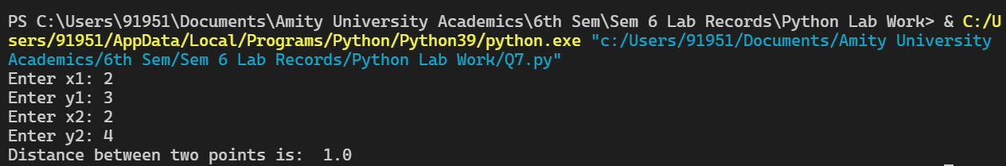

1. Write a Python program to print out all even numbers from a given numbers list in the same order and stop the printing if any numbers that come after 237 in the sequence.

numbers = [

386, 462, 47, 418, 907, 344, 236, 375, 823, 566, 597, 978, 328, 615, 953, 345,

399, 162, 758, 219, 918, 237, 412, 566, 826, 248, 866, 950, 626, 949, 687, 217,

815, 67, 104, 58, 512, 24, 892, 894, 767, 553, 81, 379, 843, 831, 445, 742, 717,

958,743, 527 ]

Ans-

numbers = [22,33,44,68,89,23,237,45,333]

for i in numbers:

if i > 237:

break

elif i % 2 == 0:

print(i)

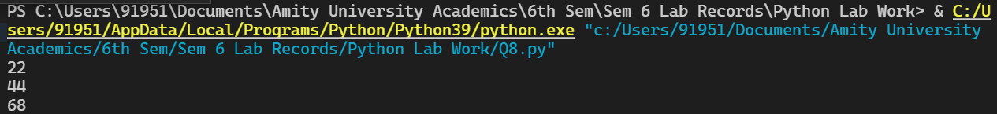

**9.Implement Stack in python.**

Ans :

stack1 = []

stack2 = []

i = 0

while(i == 0):

ch = int(input("Press 1 to add element in stack1,2 to pop element from stack1, 3 to add element in stack2 and 4 to remove element from stack2 : "))

if ch == 1:

val = int(input("Enter value to add in stack 1 : "))

stack1.append(val)

elif ch == 2:

if len(stack1) == 0:

print("Stack Underflows !")

else:

val = stack1.pop()

print("Element removed from stack 1 is : "+str(val))

elif ch == 3:

val = int(input("Enter value to add in stack 2 : "))

stack2.append(val)

elif ch == 4:

if len(stack1) == 0:

print("Stack Underflows !")

else:

val = stack2.pop()

print("Element removed from stack 2 is : "+str(val))

else:

print("Invalid Choice !")

print("Stack1 : "+str(stack1))

print("Stack2 : "+str(stack2))

i = int(input("Press 0 to continue......"))

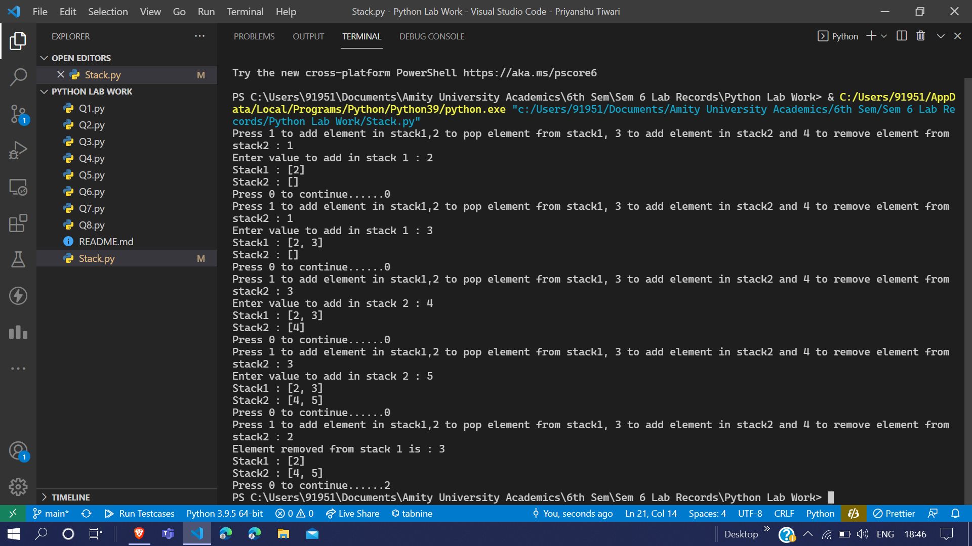

**10.Implement Binary Tree in python.**

from binarytree import build

n = int(input("Enter nodes in level order one by one : "))

print("Enter nodes in level order one by one : ")

i = 0

nodes = []

while i != n:

nodes.append(int(input()))

i = i+1

binary_tree = build(nodes)

print('Binary tree from list :', binary_tree)

print('List from binary tree :', binary_tree.values)

